**1.Generation of elementary signal in continuous - time**

clc;

close all;

clear all;

**a)Unit step function**

t=-5:0.01:5;

step=[zeros(1,500),ones(1,501)];

subplot(3,2,1);

plot(t,step);

axis([-5 5 0 1.5]);

xlabel('Discrete time n -->');

ylabel('Amplitude-->');

title('Unit step sequence');

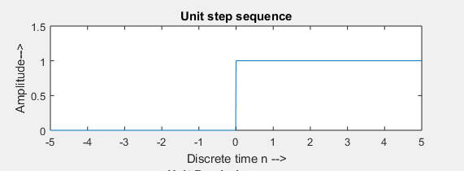

**Figure1: Unit step function**

**b)Unit ramp function**

t = 0:0.01:6;

ramp=t;

subplot(3,2,2);

plot(t,ramp);

xlabel('Discrete time n -->');

ylabel('Amplitude-->');

title('Unit Ramp sequence');

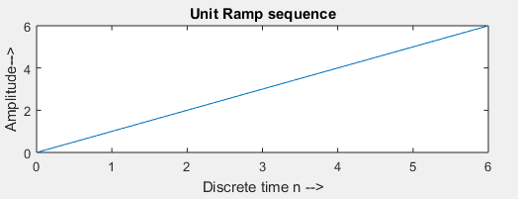

**Figure2: Unit step function**

**c)Unit parabolic function**

t = 0:0.01:6;

parabola=0.5*(t.^2);

subplot(3,2,3);

plot(t,parabola);

xlabel('Discrete time n -->');

ylabel('Amplitude-->');

title('Unit Parabola sequence');

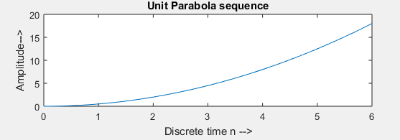

**Figure3: Unit Parabola function**

**d)Unit impulse function**

t =-1:0.001:1

impulse=[zeros(1,1000),ones(1,1),zeros(1,1000)];

subplot(3,2,4);

plot(t,impulse);

axis([-1 1 0 1.5]);

xlabel('Discrete time n -->');

ylabel('Amplitude-->');

title('Unit Impulse sequence');

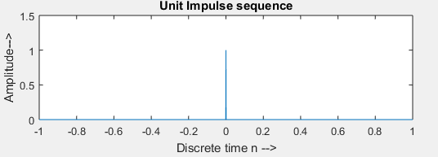

**Figure4: Unit Impulse function**

**e)Real exponential function**

t = -10:0.1:10;

real_ex = 2.*(1.2.^t);

subplot(3,2,5);

plot(t,real_ex);

xlabel('Discrete time n -->');

ylabel('Amplitude-->');

title('Real exponential ');

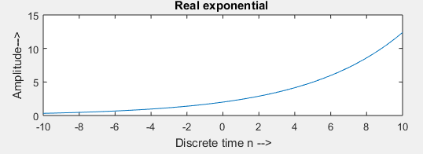

**Figure5: Real exponential function**

**f)Complex exponential function**

t= [0:0.1:10];

fi=exp(1i*pi/6./t);

%fi=exp(1i*pi/6.*t);

subplot(3,2,6);

plot(t,real(fi),t,imag(fi));

legend({'real','imag'})

xlabel('Discrete time n -->');

ylabel('Amplitude-->');

title('Complex exponential'); 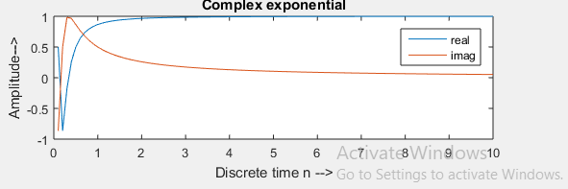

**Figure6: Complex exponential function**

**2.Generation of elementary signal in discrete time.**

close all;

clear all;

**a)Unit step function**

n = -10:1:10;

step=[zeros(1,10),ones(1,11)];

subplot(3,2,1);

stem(n,step);

xlabel('Discrete time n -->');

ylabel('Amplitude-->');

title('Unit step sequence');

axis([-10 10 0 1.2]);

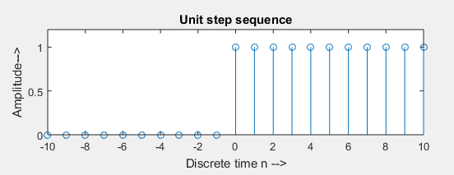

**Figure7: Unit step function**

**b)Unit ramp function**

n= 0:1:10;

ramp=n;

subplot(3,2,2);

stem(n,ramp);

xlabel('Discrete time n -->');

ylabel('Amplitude-->');

title('Unit ramp sequence');

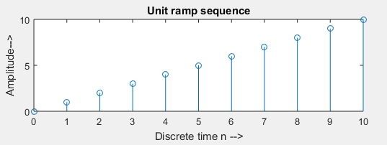

**Figure8: Unit ramp function**

**c)Unit parabolic function**

n = 0:1:10

parabola=0.5*(n.^2);

subplot(3,2,3);

stem(n,parabola);

xlabel('Discrete time n -->');

ylabel('Amplitude-->');

title('Unit parabolic sequence');

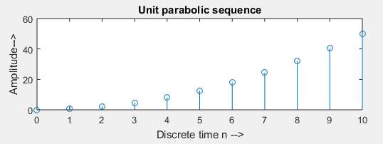

**Figure9: Unit parabolic function**

**d)Unit impulse function**

n=-10:1:10;

impulse=[zeros(1,10),ones(1,1),zeros(1,10)];

subplot(3,2,4);

stem(n,impulse);

xlabel('Discrete time n -->');

ylabel('Amplitude-->');

title('Unit Impulse sequence');

axis([-10 10 0 1.2]);

subplot(3,2,2);

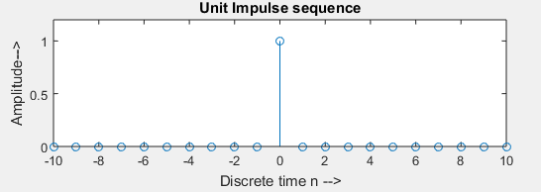

**Figure10: Unit Impulse function**

**e)Real exponential function**

n = -10:1:10;

%for 0<a<1

a = 0.8;

real_ex = a.^n;

subplot(3,2,5);

stem(n,real_ex);

xlabel('Discrete time n -->');

ylabel('Amplitude-->');

title('Real exponential ');

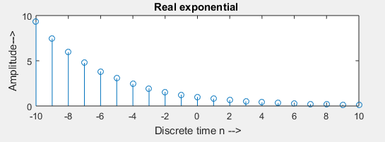

**Figure11: Real exponential function**

**3.Genaration of following signal both in continuous and discrete time**

clc;

close all;

clear all;

**a)Continuous Sine function**

t=-5:0.01:5;

y=sin(pi*t);

subplot(4,2,1);

plot(t,y);

axis([-5 5 -1 1.5]);

xlabel('Discrete time n -->');

ylabel('Amplitude-->');

title('Continuous Sine function');

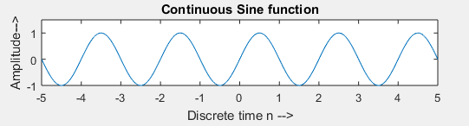

**Figure12: Continuous Sine function**

**a)Discrete Sine function**

t=-5:0.5:5;

y=sin(pi*t);

subplot(4,2,2);

stem(t,y);

axis([-5 5 -1 1.5]);

xlabel('Discrete time n -->');

ylabel('Amplitude-->');

title('Discrete Sine function');

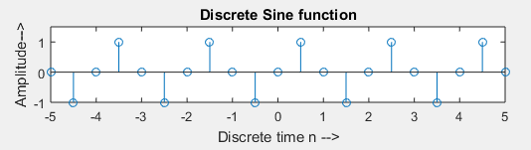

**b)Continuous Square function**

t=-5:0.01:5;

y=square(sin(pi*t));

subplot(4,2,3);

plot(t,y);

axis([-5 5 -1 1.5]);

xlabel('Discrete time n -->');

ylabel('Amplitude-->');

title('Continuous Square function');

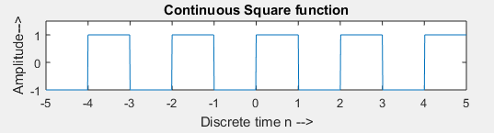

%Discrete Square function

t=-5:1:5;

y=square(sin(pi*t));

subplot(4,2,4);

stem(t,y);

axis([-5 5 -1 1.5]);

xlabel('Discrete time n -->');

ylabel('Amplitude-->');

title('Discrete Square function');

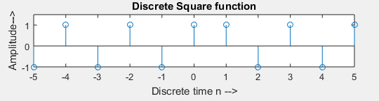

**c)Continuous Rectangular function**

t=-5:0.01:5;

width=2;

y=rectpuls(t,width);

subplot(4,2,5);

plot(t,y);

xlabel('Discrete time n -->');

ylabel('Amplitude-->');

title('Continuous Rectangular function');

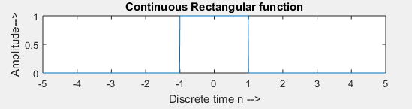

%Discrete Rectangular function

t=-5:5;

width=2;

y=rectpuls(t,width);

subplot(4,2,6);

stem(t,y);

xlabel('Discrete time n -->');

ylabel('Amplitude-->');

title('Discrete Rectangular function');

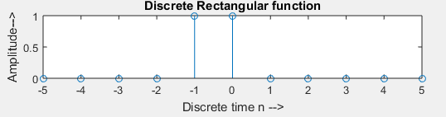

**d)Continuous Triangular function**

t = -5:0.01:5;

width=2;

y=tripuls(t,width);

subplot(4,2,7);

plot(t,y);

xlabel('Discrete time n -->');

ylabel('Amplitude-->');

title('Continuous Triangular function');

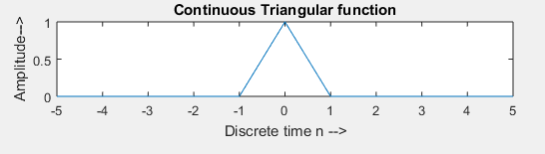

%Discrete Triangular function

t = -5:0.25:5;

width=2;

y=tripuls(t,width);

subplot(4,2,8);

stem(t,y);

xlabel('Discrete time n -->');

ylabel('Amplitude-->');

title('Discrete Triangular function');

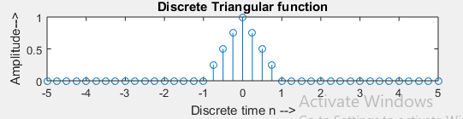

1. **Multiplication of following two signals(both in continuous an discrete nature)**

**a)Unit step function and sinusoidal signal**

t=-10:.01:10;

for i=1:length(t)

if t(i)<0

y(i)=0;

else if t(i)>=0

y(i)=1;

end

end

end

subplot(2,2,1);

plot(t,y);

axis([-2 2 -2 2]);

xlabel('Time n-->');

ylabel('Amplitude-->');

title('Unit Step Sequence');

s=sin(pi*t);

subplot(2,2,2);

plot(t,s);

xlabel('Time n-->');

ylabel('Amplitude-->');

title('Sinusoidal');

for i=1:length(y);

add(i)=y(i)*s(i);

end

subplot(2,2,3:4);

plot(t,add);

axis([-8 8 -2 2]);

xlabel('Time n-->');

ylabel('Amplitude-->');

title('Multiplication of Unit Step and sinusoidal Sequence');

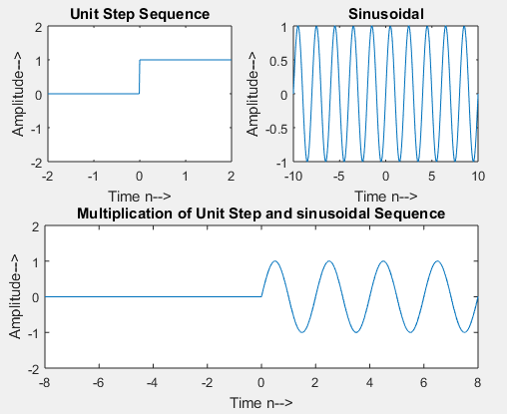

**b) Unit parabolic function and Unit impulse function**

% unit parabolic discrete sequence

n=0:1:10;

parabola=0.5*(n.^2);

subplot(3,2,1);

stem(n,parabola);

xlabel('Discrete time n------>');

ylabel('Amplitude------>');

title('unit parabolic discrete sequence');

% unit parabolic continuous sequence

n=0:1:10;

parabola=0.5*(n.^2);

subplot(3,2,2);

plot(n,parabola);

xlabel('Continuous time n------>');

ylabel('Amplitude------>');

title('unit parabolic discrete sequence');

% unit impulse discrete sequence

n=-10:1:10;

impulse=[zeros(1,10),ones(1,1),zeros(1,10)];

subplot(3,2,3);

stem(n,impulse);

xlabel('Discrete time n------>');

ylabel('Amplitude------>');

title('unit impulse discrete sequence');

axis([-10 10 0 1.2]);

% unit impulse continuous sequence

n=-10:1:10;

impulse=[zeros(1,10),ones(1,1),zeros(1,10)];

subplot(3,2,4);

plot(n,impulse);

xlabel('Continuous time n------>');

ylabel('Amplitude------>');

title('unit impulse discrete sequence');

axis([-10 10 0 1.2]);

%parabolic multiply impulse for discrete

n=-10:1:10;

for i=1:length(parabola);

add(i)=parabola(i)*impulse(i);

end

subplot(3,2,5);

stem(n,add);

axis([-8 8 -2 2]);

xlabel('Time n-->');

ylabel('Amplitude-->');

title('Multiplication of parabola and impulse for discrete');

%parabolic multiply impulse for continuous

n=-10:1:10;

for i=1:length(parabola);

add(i)=parabola(i)*impulse(i);

end

subplot(3,2,6);

plot(n,add);

axis([-8 8 -2 2]);

xlabel('Time n-->');

ylabel('Amplitude-->');

title('Multiplication of parabola and impulse for continuous');

**c) Real exponential function and Rectangular signal**

% Disctrete real exponential

n=0:10;

a=3;

x=a.^n;

subplot(3,2,1);

stem(n,x);

xlabel('Time-->');

ylabel('Amplitude-->');

title('Disctrete real exponential');

% Continuous real exponential

n=0:10;

a=3;

x=a.^n;

subplot(3,2,2);

plot(n,x);

xlabel('Time-->');

ylabel('Amplitude-->');

title('Continuous real exponential');

% discrete

f=1000;

t=-1:1/f:1;

a=rectpuls(t);

subplot(3,2,3);

stem(t,a);

xlabel('Discrete Time Period');

ylabel('Amplitude');

title('Dscrete Rectangular Signal');

% continuous

f=1000;

t=-1:1/f:1;

a=rectpuls(t);

subplot(3,2,4);

plot(t,a);

xlabel('Continuous Time Period');

ylabel('Amplitude');

title('Continuous Rectangular Signal');

%realexponential multiply rectangular for discrete

mul=x.*a;

subplot(3,2,5);

stem(mul);

title('Realexponential multiply rectangular for discrete');

%realexponential multiply rectangular for continuous

mul=x.*a;

subplot(3,2,6);

plot(mul);

title('Realexponential multiply rectangular for continuous');

**4. Generation of sinusoidal and Gaussian signals both in continuous and discrete nature.**

**a) Sinusoidal signal**

**Sample Code:**

t=-.05:.001:.05;

f=50;

a=3;

y=a*sin(2*pi*f*t);

subplot(2,1,1);

plot(t,y);

xlabel('amplitude');

ylabel('time');

title('sinusoidal');

t=-.05:.001:.05;

f=50;

a=3;

y=a*sin(2*pi*f*t);

subplot(2,1,2);

stem(t,y);

xlabel('amplitude');

ylabel('time');

title('sinusoidal');

**Output:** 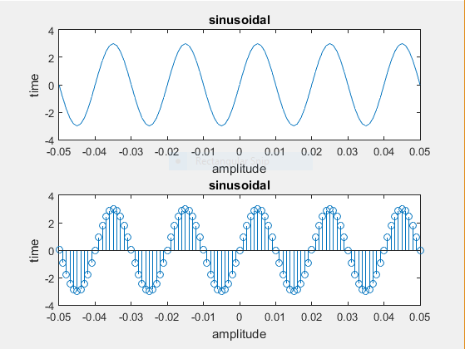

**Figure :** Sinusoidal signal for continuous & discrete nature

**6. Addition of following two signals (both in continuous and discrete nature).**

**a 1) Unit step function and sinusoidal signal continuous form**

**Sample Code:**

clear all;

clc;

t=-10:.01:10;

for i=1:length(t)

if t(i)<0

y(i)=0;

else if t(i)>=0

y(i) = 1;

end

end

end

subplot(2,2,1);

plot(t,y);

axis([-2 2 -2 2]);

xlabel(' time n-->');

ylabel('Amplitude-->');

title('Unit Step sequence');

s=sin(pi*t);

subplot(2,2,2);

plot(t,s);

xlabel('time');

ylabel('Amplitude');

title('sinusoidal');

for i=1:length(y)

add(i) = y(i) + s(i);

end

subplot(2,2,3:4);

plot(t,add);

axis([-8 8 -2 2]);

xlabel(' time n-->');

ylabel('Amplitude-->');

title('Addition ot unit step and sinusoidal function');

**Output:** 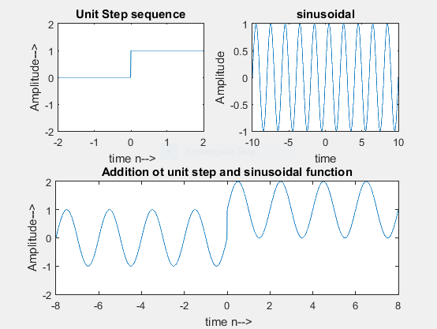

**Figure :** Add Unit step function and sinusoidal signal continuous form

**A 2) Unit step function and sinusoidal signal discrete form**

**Sample Code:**

clear all;

clc;

t=-10:.1:10;

for i=1:length(t)

if t(i)<0

y(i)=0;

else if t(i)>=0

y(i) = 1;

end

end

end

subplot(2,2,1);

stem(t,y);

axis([-2 2 -2 2]);

xlabel(' time n-->');

ylabel('Amplitude-->');

title('Unit Step sequence');

s=sin(pi*t);

subplot(2,2,2);

stem(t,s);

xlabel('amplitude');

ylabel('time');

title('sinusoidal');

for i=1:length(y)

add(i) = y(i) + s(i);

end

subplot(2,2,3:4);

stem(t,add);

axis([-8 8 -2 2]);

xlabel(' time n-->');

ylabel('Amplitude-->');

title('Addition of unit step and sinusoidal function');

Output:

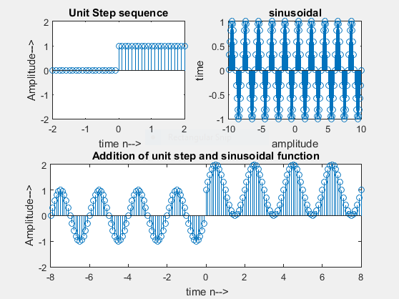

**Figure :** Add Unit step function and sinusoidal signal discrete form

**b 1) Unit parabolic function & unit impulse function continuous form**

**Sample Code:**

clear all;

clc;

t=-10:.01:10;

parabola=.5*(t.^2);

subplot(2,2,1);

plot(t,parabola);

xlabel(' time n-->');

ylabel('Amplitude-->');

title('Unit Parabola sequence');

for i=1:length(t)

if t(i)<0

y(i)=0;

else if t(i)==0

y(i) = 1;

else if t(i)>0

y(i)=0;

end

end

end

end

subplot(2,2,2);

plot(t,y);

xlabel(' time n-->');

ylabel('Amplitude-->');

title('Unit Impulse sequence');

for i=1:length(y)

add(i) = parabola(i)+y(i);

end

subplot(2,2,3:4);

plot(t,add);

xlabel(' time n-->');

ylabel('Amplitude-->');

axis([-2 2 0 1]);

title('Addition ot unit parabolic and impulse function');

**Output:**

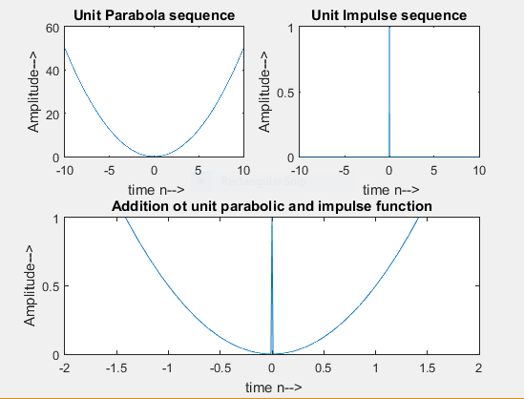

**Figure :**Add Unit parabolic function & unit impulse function continuous form

**b 1) Unit parabolic function & unit impulse function discrete form**

**Sample Code:**

clear all;

clc;

t=-10:.1:10;

parabola=.5*(t.^2);

subplot(2,2,1);

stem(t,parabola);

xlabel(' time n-->');

ylabel('Amplitude-->');

title('Unit Parabola sequence');

for i=1:length(t)

if t(i)<0

y(i)=0;

else if t(i)==0

y(i) = 1;

else if t(i)>0

y(i)=0;

end

end

end

end

subplot(2,2,2);

stem(t,y);

xlabel(' time n-->');

ylabel('Amplitude-->');

title('Unit Impulse sequence');

for i=1:length(y)

add(i) = parabola(i)+y(i);

end

subplot(2,2,3:4);

stem(t,add);

xlabel(' time n-->');

ylabel('Amplitude-->');

axis([-2 2 0 1]);

title('Addition of unit parabolic and impulse function');

**Output:**

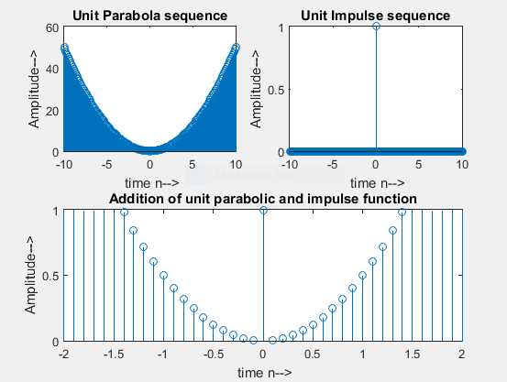

**Figure :**Add Unit parabolic function & unit impulse function discrete form

**c 1) Real exponential function & Rectangular signal**

**Sample Code:**

f=1000;

n=-10:.1/f:10;

a=3;

x=a.^n;

subplot(2,2,1);

plot(n,x);

xlabel('time-->');

ylabel('amplitude-->');

title(' Continuous real exponential');

y=rectpuls(n);

subplot(2,2,2);

plot(n,y);

title('Continuous rectangular');

for i=1:length(x)

add(i)=x(i)+y(i);

end

subplot(2,2,3:4);

plot(n,add);

axis([-4 4 -2 2]);

xlabel(' time n-->');

ylabel('Amplitude-->');

title('Addition real exponential and rectangular function');

**Output:**

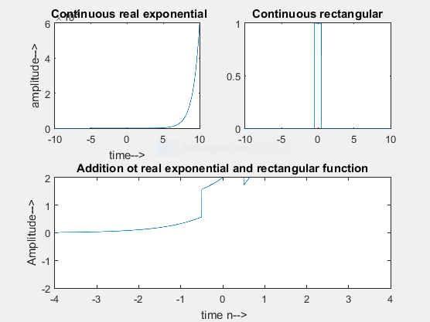

**Figure :** Add Real exponential function & Rectangular signal continuous form

**c 2) Real exponential function & Rectangular signal discrete form**

**Sample Code:**

f=1000;

n=-10:.1/f:10;

a=3;

x=a.^n;

subplot(2,2,1);

stem(n,x);

xlabel('time-->');

ylabel('amplitude-->');

title(' Continuous real exponential');

y=rectpuls(n);

subplot(2,2,2);

stem(n,y);

title('Continuous rectangular');

for i=1:length(x)

add(i)=x(i)+y(i);

end

subplot(2,2,3:4);

stem(n,add);

axis([-4 4 -2 2]);

xlabel(' time n-->');

ylabel('Amplitude-->');

title('Addition ot real exponential and rectangular function');

**Output:**

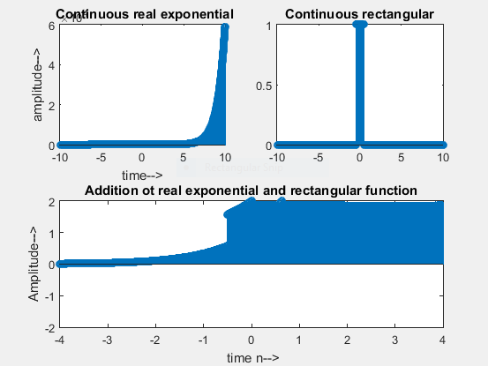

**Figure :** Add Real exponential function & Rectangular signal discrete form

**d) complex exponential function & triangular signal**

**Sample Code:**

% Disctrete complex exponential

n=-1:.001:1;

a=2;

cexp=exp((a+3j)*n);

subplot(3,2,1);

stem(n,cexp);

xlabel('Time');

ylabel('Amplitude');

title('Disctrete complex exponential');

% Continuous complex exponential

t=-1:.001:1;

a=2;

cexp=exp((a+3j)*t);

subplot(3,2,2);

plot(t,cexp);

xlabel('Time');

ylabel('Amplitude');

title('Continuous complex exponential');

% discrte triangular function

%f2=100;

%t2=-1:1/f:1;

n=-1:.001:1;

tri=tripuls(n);

subplot(3,2,3);

stem(n,tri);

xlabel('Discrete');

ylabel('Amplitude');

title('Triangular Signal');

% continuous triangular function

%f=100;

%t=-1:1/f:1;

t=-1:.001:1;

tri=tripuls(t);

subplot(3,2,4);

plot(t,tri);

xlabel('Continuous');

ylabel('Amplitude');

title('Triangular Signal');

% addition of complexExponential and trinangular function(discrete time)

for i=1:length(cexp)

add(i)=cexp(i)+tri(i);

end

subplot(3,2,5);

stem(n,add);

xlabel('Discrete Time');

ylabel('Amplitude');

title('ComplexExponential + Triangular');

% addition of complexExponential and trinangular function(continuous time)

for i=1:length(cexp)

add(i)=cexp(i)+tri(i);

end

subplot(3,2,6);

plot(t,add);

xlabel('Continuous Time');

ylabel('Amplitude');

title('ComplexExponential + Triangular');

**Output:**

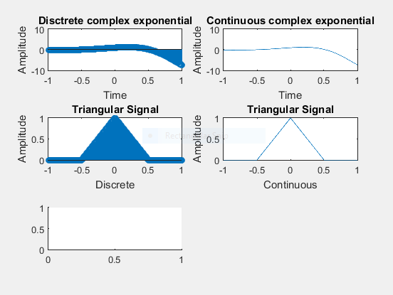

**Figure :** Add complex exponential & triangular signal

**35.Find the autocorrelation function of the sequence**

**a)x(n)= sin(n)**

**b)x(n)=[1,2,3,4]**

**Sample Code:**

clc;

clear all;

close all;

% x(n)=sin(n);

n=0:1:10;

x1=sin(n);

y1=xcorr(x1);

subplot(2,1,1);

stem(y1);

xlabel('n');

ylabel('y1(n)');

title('autocorrelation of x(t)=sin(t)');

% x(n)=[1,2,3,4]

n=0:1:3;

x2=[1 2 3 4];

y2=xcorr(x2);

subplot(2,1,2);

stem(y2);

xlabel('n');

ylabel('y2(n)');

title('autocorrelation of x(n)=[1,2,3,4]');

**Output:**

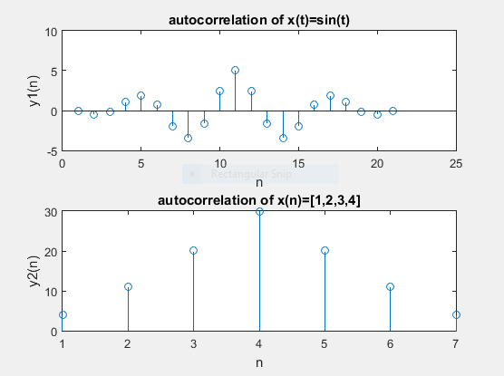

**Figure :** autocorrelation function of the sequence

9. Multiplication of any two or more types of signals (both in continuous and discrete nature)

Sample code:

%x1(t)=5exp(-at) for discrete;

t=0:0.001:5;

a=1.2;

x1=5*exp(-a*t);

subplot(3,2,1);

stem(t,x1);

title('First signal x1(t) for discrete');

%x1(t)=5exp(-at) for continuous;

t=0:0.001:5;

a=1.2;

x1=5*exp(-a*t);

subplot(3,2,2);

plot(t,x1);

title('First signal x1(t) for continuous');

%x2(t)=2sin(wt) for discrete;

f=1;

x2=2*sin(2*pi*f*t);

subplot(3,2,3);

stem(t,x2);

title('Second signal x2(t) for discrete');

%x2(t)=2sin(wt) for continuous;

f=1;

x2=2*sin(2*pi*f*t);

subplot(3,2,4);

plot(t,x2);

title('Second signal x2(t) for continuous');

%Multiplication of x1(t) and x2(t) for discrete

y=x1.*x2;

subplot(3,2,5);

stem(t,y);

title('Multiplication of x1(t) and x2(t) for discrete');

%Multiplication of x1(t) and x2(t) for continuous

y=x1.*x2;

subplot(3,2,6);

plot(t,y);

title('Multiplication of x1(t) and x2(t) for continuous');

Output:

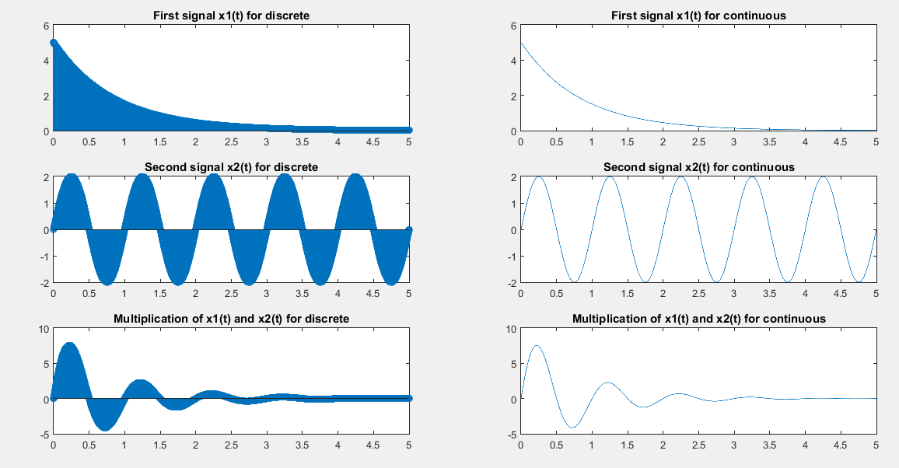

Figure: Multiplication of any two or more types of signals (both in continuous and discrete nature)

**10. Show the delayed and advanced version for the following signal**

**a) Unit step function:**

**Sample code:**

% unit step continuous sequence

n=-10:1:10;

step=[zeros(1,10),ones(1,11)];

subplot(2,2,1);

plot(n,step);

xlabel('Continuous time n------>');

ylabel('Amplitude------>');

title('unit step discrete sequence');

axis([-10 10 0 1.2]);

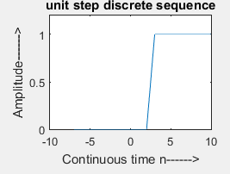

Figure: Unit step function

% unit step continuous sequence

n=-10:1:10;

step=[zeros(1,10),ones(1,11)];

subplot(2,2,2);

plot(n-3,step);

xlabel('Continuous time n------>');

ylabel('Amplitude------>');

title('unit step discrete sequence');

axis([-10 10 0 1.2]);

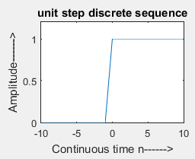

Figure: Delayed version of unit step function

% unit step continuous sequence

n=-10:1:10;

step=[zeros(1,10),ones(1,11)];

subplot(2,2,3);

plot(n+3,step);

xlabel('Continuous time n------>');

ylabel('Amplitude------>');

title('unit step discrete sequence');

axis([-10 10 0 1.2]);



Figure: Advanced version of unit step function

**11. Show the compressed and expanded version for all signals by applying the time scaling operation in the output of addition of following two signals:**

**a) Unit step function and sinusoidal signal:**

**Sample code:**

clear all;

clc;

t=-10:.01:10;

for i=1:length(t)

if t(i)<0

y(i)=0;

else if t(i)>=0

y(i) = 1;

end

end

end

subplot(2,3,1);

plot(t,y);

axis([-2 2 -2 2]);

xlabel(' time n-->');

ylabel('Amplitude-->');

title('Unit Step sequence');

s=sin(pi*t);

subplot(2,3,2);

plot(t,s);

xlabel('amplitude');

ylabel('time');

title('sinusoidal');

for i=1:length(y)

add(i) = y(i) + s(i);

end

subplot(2,3,3);

plot(t,add);

axis([-8 8 -2 2]);

xlabel(' time n-->');

ylabel('Amplitude-->');

title('Addition of unit step and sinusoidal function');

subplot(2,3,4);

plot(2*t,add);

axis([-20 20 -2 2]);

xlabel(' time n-->');

ylabel('Amplitude-->');

title('Expanded of unit step and sinusoidal function');

subplot(2,3,5);

plot(t/2,add);

axis([-8 8 -2 2]);

xlabel(' time n-->');

ylabel('Amplitude-->');

title('Compressed of unit step and sinusoidal function');

Output:

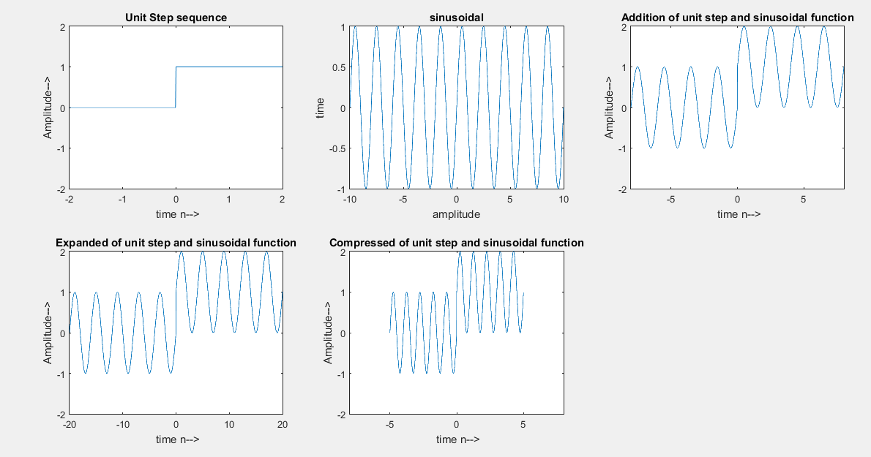

Figure: Compressed and expanded version of the signal of addition of unit step and sinusoidal function

**b) Unit parabolic function and unit impulse function:**

**Sample code:**

clear all;

clc;

t=-10:.01:10;

parabola=.5*(t.^2);

subplot(3,2,1);

plot(t,parabola);

xlabel(' time n-->');

ylabel('Amplitude-->');

title('Unit Parabola sequence');

for i=1:length(t)

if t(i)<0

y(i)=0;

else if t(i)==0

y(i) = 1;

else if t(i)>0

y(i)=0;

end

end

end

end

subplot(3,2,2);

plot(t,y);

xlabel(' time n-->');

ylabel('Amplitude-->');

title('Unit Impulse sequence');

for i=1:length(y)

add(i) = parabola(i)+y(i);

end

subplot(3,2,3);

plot(t,add);

xlabel(' time n-->');

ylabel('Amplitude-->');

axis([-2 2 0 1]);

title('Addition of unit parabolic and impulse function');

subplot(3,2,4);

plot(2*t,add);

xlabel(' time n-->');

ylabel('Amplitude-->');

axis([-4 4 0 1]);

title('Expanded of unit parabolic and impulse function');

subplot(3,2,5);

plot(t/2,add);

xlabel(' time n-->');

ylabel('Amplitude-->');

axis([-4 4 0 1]);

title(' Compressed of unit parabolic and impulse function');

**Output:**

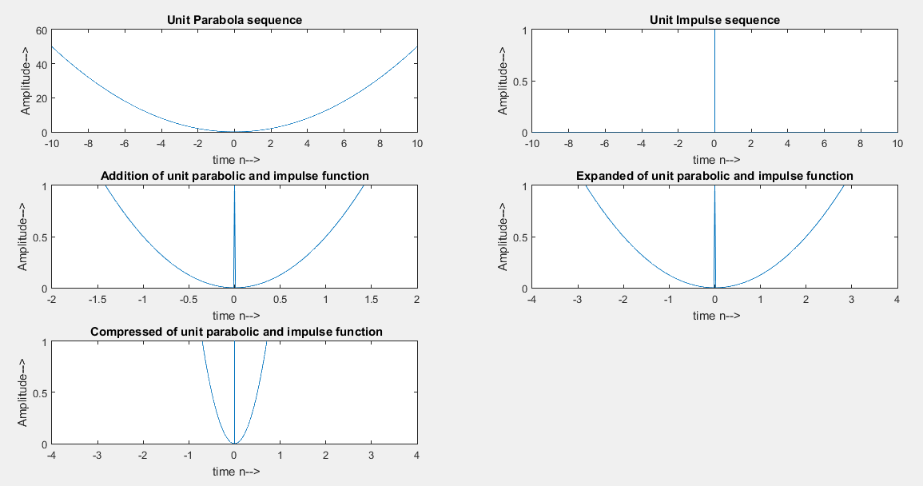

Figure: Compressed and expanded version of the signal of addition of unit parabolic function and unit impulse function

**13. Generation of discrete-time sequence of the following:**

x(n)= u(n+3)+ 5u(n-15)+4u(n+10);

**Sample code:**

n = -20:1:20;

u=[zeros(1,20),ones(1,21)];

u1= [zeros(1,17),ones(1,24)];

u2=[zeros(1,35),ones(1,6)];

u2 = 5*u2;

u3=[zeros(1,10),ones(1,31)];

u3 = 4*u3;

x=u1+u2+u3;

subplot(3,3,1);

plot(n,u);

subplot(3,3,2);

plot(n,u1);

subplot(3,3,3);

title('Figure u2');

plot(n,u2);

subplot(3,3,4);

plot(n,u3);

subplot(3,3,5);

plot(n,x);

subplot(3,3,6);

stem(n,u1);

subplot(3,3,7);

stem(n,u2);

subplot(3,3,8);

stem(n,u3);

subplot(3,3,9);

stem(n,x);

**Output:**

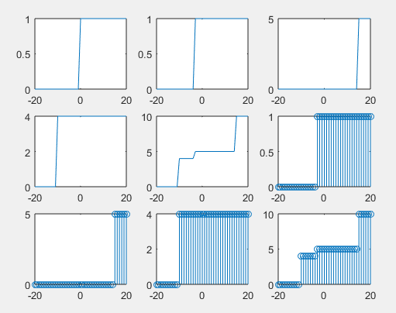

**Figure: Given discrete-time sequence**

**14. Find even and odd component of a continuous time signal.**

**Sample Code:**

t= -10:.01:10;

u = .5*sign(t)+0.5;

x = exp(-2*t).*u;

subplot(3,2,1);

stem(t,x);

x1= fliplr(x);

subplot(3,2,2);

stem(t,x1);

%even signal

xe = .5*(x+x1);

subplot(3,2,3);

stem(t,xe);

title('Even signal');

%odd signal

xo = .5*(x-x1);

subplot(3,2,4);

stem(t,xo);

title('Odd signal');

**Output:**

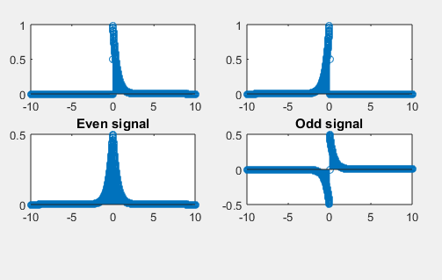

**Figure: Even and odd components of given continuous -time signal**

**15.Evaluate even and odd components of any signal.**

**Sample Code:**

t = -10:.01:10;

%actual function

u = .5*sign(t)+.5;

x1 = exp(-.5*t).*u;

subplot(4,1,1);

stem(t,x1);

x2 = fliplr(x1);

subplot(4,1,2);

stem(t,x2);

%EVEN

x3 = .5*(x1+x2);

subplot(4,1,3);

stem(t,x3);

title('Even signal');

%odd

x4 = .5*(x1-x2);

subplot(4,1,4);

stem(t,x4);

title('Odd signal');

**Output:**

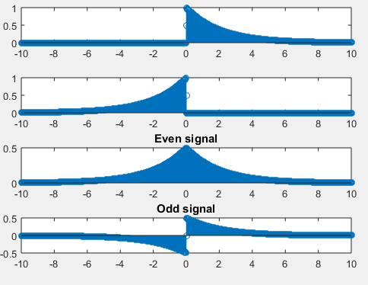

**Figure: Even and odd components of a signal**

**16. Find linear convolution of two discrete-time sequence.**

**Sample Code:**

n = -20:20;

x = sin(n);

h = [-1,-2,8,-2,-1];

N = length(x);

M = length(h);

Ny = N + M -1;

y = zeros(1,Ny);

for i = 1:N

for k = 1:M

y(i+k-1) = y(i+k-1) + h(k)*x(i);

end

end

m = 0: Ny-1;

% Make plot

figure

plot(m,y,'linewidth',3,'color','m')

grid;

a = title('Output of an LTI System y(n)');

set(a,'fontsize',14);

a = ylabel('y(n)');

set(a,'Fontsize',14);

a = xlabel('n');

set(a,'Fontsize',14);

% Using matlab built in function (you get the same results)

figure

y2 = conv(x,h);

plot(m,y2,'linewidth',3,'color','r')

grid;

a = title('Output y(n) using conv(x,h)');

set(a,'fontsize',14);

a = ylabel('y(n)');

set(a,'Fontsize',14);

a = xlabel('n ');

set(a,'Fontsize',14);

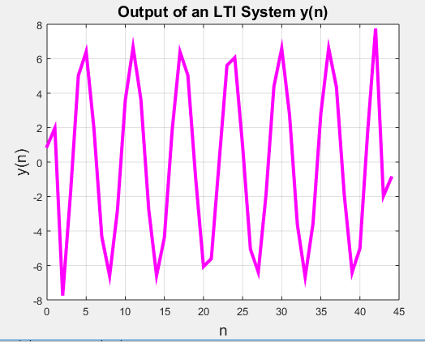**Output:**

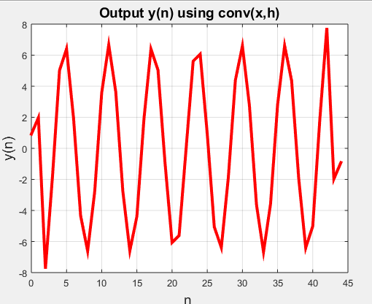

**Figure: Linear convolution of two discrete-time sequence**

**28. Find Fourier Transform and Inverse Fourier Transform of a given signal.**

**Sample code:**

syms t;

f=exp(-t^2);

subplot(3,1,1);

disp('Input signal is:');

disp(f);

%Fourier transform

FT=fourier(f);

disp('Fourier transform of signal is:');

disp(FT);

%Fourier inverse transform

IFT=ifourier(FT);

disp('Inverse Fourier transform of signal is:');

disp(IFT);

**Output:**

Given equation is:

exp(-t^2)

Fourier equation of given equation is:

pi^(1/2)*exp(-w^2/4)

Inverse fourier equation of given signal is:

exp(-x^2/4)/(2*pi^(1/2))

**29. Fourier transform of a rectangular pulse.**

**Sample Code:**

syms t w

%input signal x(t)

x=2*(heaviside(t+2)-heaviside(t-2));

subplot(3,1,1);

ezplot(x,[-2,2]);

axis([-2.5 2.5 0 2.5]);

%fourier transform

x=int(x*exp(-1i*w*t),t,-5,5);

x1=simplify(x);

disp('The fourier trnsform of x(t) is :');

disp(x1);

subplot(3,1,2);

ezplot(x1);

%magnitude response

x2=sqrt((real(x1).^2)+(imag(x1).^2));

subplot(3,1,3);

ezplot(x2);

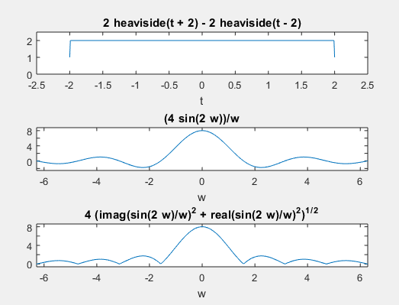**Output:**

**Figure: Fourier transform of a rectangular pulse.**

**38. Generation of z transform and inverse z transform of a sequence.**

**Sample Code:**

without built in function new

y=[1 2 3 4 5];

display('Display input');

disp(y);

Y=0;

len=length(y);

z=sym('z');

for n=0:len-1

Y=Y+y(n+1)*z^(-n);

end

disp('Display output-->');

disp(Y);

% without built in function old

x=[1 2 3 4 5];

X=0;

l=length(x);

z=sym('z');

for n=0:l-1

X=X+x(n+1)*z^(-n);

end

disp('Display output');

disp(X);

**Output:**

Display input

1 2 3 4 5

Display output

2/z + 3/z^2 + 4/z^3 + 5/z^4 + 1

Display output

2/z + 3/z^2 + 4/z^3 + 5/z^4 + 1